Yes, I’ve used automation extensively in cloud environments, particularly with AWS. For example:
- Infrastructure as Code (IaC): I’ve automated the provisioning of EC2 instances, VPCs, and IAM roles using tools like AWS CloudFormation and Terraform. This eliminated manual setup, ensured consistency, and made rollback easier.
- CI/CD Pipelines: I’ve set up automated deployments with AWS CodePipeline and CodeBuild, so application updates move from commit to production with minimal human intervention. This reduced deployment errors and sped up release cycles.
- Monitoring & Compliance: I’ve automated log collection and compliance checks using AWS Config and CloudWatch. This helped enforce security baselines and detect drift without manual audits.
- Scaling & Cost Optimization: Auto Scaling groups and Lambda-based automation scripts ensured resources scaled up or down based on demand, keeping costs under control while maintaining performance.
The reason behind all this automation was simple: efficiency, consistency, and reliability. Manual processes are error-prone and slow, whereas automation guarantees repeatability and frees up time for higher-value tasks.
If you haven’t yet automated cloud tasks, the biggest benefits you can expect are:
- Faster provisioning of resources
- Reduced human error
- Easier compliance enforcement
- Cost savings through dynamic scaling
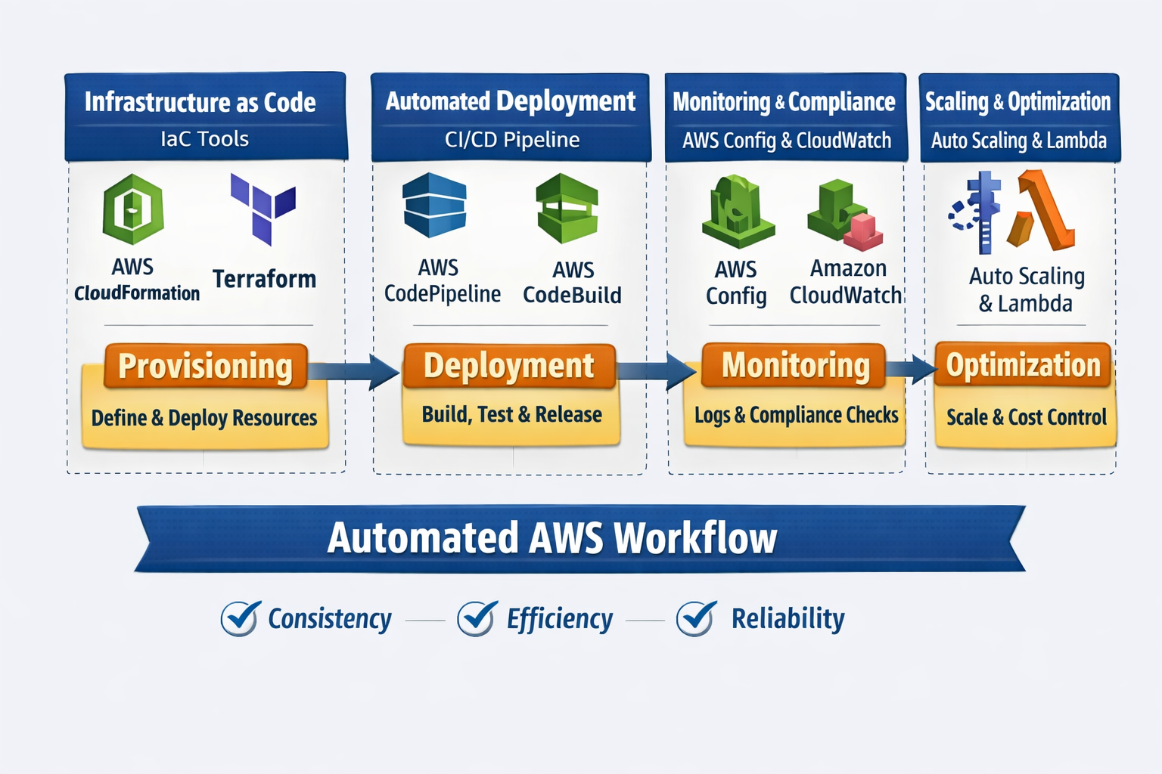This visualization shows the four key stages of AWS automation:
- Provisioning (Infrastructure as Code) – Define and deploy resources using CloudFormation or Terraform.
- Deployment (CI/CD Pipeline) – Build, test, and release applications automatically with CodePipeline and CodeBuild.
- Monitoring & Compliance – Track logs and enforce rules with CloudWatch and AWS Config.
- Scaling & Optimization – Use Auto Scaling and Lambda to adjust resources dynamically and control costs.
At the bottom, the diagram highlights the three main benefits: Consistency, Efficiency, and Reliability.

CloudFormation Extended Features
CloudFormation is a complex service that provides many features. So far in this course, you’ve seen various video lectures, hands-on labs, and discussion about CloudFormation basics (such as the Resources, Description, and Parameters sections). This supplemental reading covers some of the extended features that CloudFormation offers (such as Refs, Functions, Mapping, and Nested Stacks) to both inform you and provide you with additional resources if you want to dive deeper into CloudFormation.
REF
Imagine that you want to create both a virtual private cloud (VPC) and a security group by using the same template. You want the security group to be part of the VPC. When you declare a template, you’re not creating resources yet—you’re defining them (remember that CloudFormation templates are declarative). The resources are only effectively created when you create a stack. However, you need a VPC ID to attach a security group instance to a VPC, but the VPC doesn’t exist yet. How do you solve this issue?
The answer is to use Ref. You start by declaring the VPC as usual. Note the custom logical ID called myVPC:
myVPC: Type: AWS::EC2::VPC Properties: CidrBlock: 10.0.0.0/16
Then, when you declare the security group, you can reference the myVPC logical ID as the value for the VpcId property. To do so, use the following syntax: !Ref myVPC
InstanceSecurityGroup: Type: AWS::EC2::SecurityGroup Properties: GroupDescription: Allow http to client host VpcId: !Ref myVPC SecurityGroupIngress: - IpProtocol: tcp FromPort: 80 ToPort: 80 CidrIp: 0.0.0.0/0 SecurityGroupEgress: - IpProtocol: tcp FromPort: 80 ToPort: 80 CidrIp: 0.0.0.0/0
In summary, you can use !Ref when you want to retrieve the logical ID for a resource. It’s a feature that’s used often when writing scripts.
FUNCTIONS
Note: The functions described in this section are CloudFormation intrinsic functions, and they are not the same as AWS Lambda functions.
CloudFormation provides several built-in (intrinsic) functions to help you manage your stacks. You can use intrinsic functions in your templates to assign values to properties that aren’t available until runtime (or until the stack is created).
As you read in the previous section, you can use !Ref when you want to refer to the logical IDof other resources that are created by the same template. However, what if you want to refer to something that’s not the logical ID?
The Fn::GetAtt intrinsic function returns the value of an attribute from a resource in the template. You can use it in the following short form:
!GetAtt logicalNameOfResource.attributeName
For example, say that you want create a security group similar to the following:
InstanceSecurityGroup: Type: AWS::EC2::SecurityGroup Properties: GroupDescription: Allow http to client host VpcId: !Ref myVPC SecurityGroupIngress: - IpProtocol: tcp FromPort: 80 ToPort: 80 CidrIp: 0.0.0.0/0 SecurityGroupEgress: - IpProtocol: tcp FromPort: 80 ToPort: 80 CidrIp: 0.0.0.0/0
This resource has many attributes, such as ToPort, IpProtocol, CidrIp, and more. If you want to fetch one of these values to use somewhere else in the CloudFormation template, you can use the Fn::GetAtt intrinsic function.
For more information and samples for the Fn::GetAtt intrinsic function, see the FN::GetAtt page in the AWS CloudFormation User Guide.
When you declare a CloudFormation template, you can use other intrinsic functions, which include the following::
- Fn::Base64
- Fn::Cidr
- Condition functions
- Fn::FindInMap
- Fn::ForEach
- Fn::GetAtt
- Fn::GetAZs
- Fn::ImportValue
- Fn::Join
- Fn::Length
- Fn::Select
- Fn::Split
- Fn::Sub
- Fn::ToJsonString
- Fn::Transform
By using intrinsic functions in CloudFormation templates, you can define resources in relation to each other. CloudFormation intrinsic functions thus add more modularity and enrich the capabilities of your templates.
MAPPING
The optional Mappings section matches a key to a corresponding set of named values. As an example, suppose you want to set values based on a Region. You can create a mapping that uses the Region name as a key, and that contains the values you want to define for each specific Region. To retrieve values in a map, you use the Fn::FindInMap intrinsic function.
If you want to launch a new EC2 instance, you need an AMI (Amazon Machine Image) ID. AMI IDs are unique to each Region. For example, the AMI ID for Windows Server in the us-east-1 Region (or N. Virginia) is different from the AMI ID for Windows Server in the sa-east-1 Region (or São Paulo).
Consider this question: Instead of hardcoding AMI IDs in Region-specific templates, how could you create a resilient CloudFormation template that you can use in two different Regions, or even multiple Regions?
The answer is to use mappings.
First, you start by declaring the mapping. The following mapping shows example AMI IDs for the Amazon Linux 2023 AMI.
Mappings:
RegionMap:
us-east-1:
"AMIID": "ami-041feb57c611358bd"
sa-east-1:
"AMIID": "ami-03376b64cbb65efec"
eu-west-1:
"AMIID": "ami-0b9fd8b55a6e3c9d5"
ap-southeast-1:
"AMIID": "ami-0c85e22f0829284aa"
ap-northeast-1:
"AMIID": "ami-0fd8f5842685ca887"
After you define the mapping, you use the Fn::FindInMap intrinsic function to find and return a value in the mapping. In the instance’s resource declaration, it looks similar to the following example (note the ImageId property):
Resources: myEC2Instance: Type: "AWS::EC2::Instance" Properties: ImageId: !FindInMap [RegionMap, !Ref "AWS::Region", AMIID] InstanceType: m1.small
Note: !FindInMap is the format for the FN::FindInMap intrinsic function when it’s used in YAML CloudFormation templates. In JSON CloudFormation templates, the FN::FindInMap intrinsic function would be in the following format:
"ImageId" : { "Fn::FindInMap" : [ "RegionMap", { "Ref" : "AWS::Region" }, "AMIID"]},
Additional information: To support increased modularity in the resource declaration, you can use pseudo parameters (such as AWS::Region in the previous code examples). Pseudo parameters are parameters that are predefined by CloudFormation, so you don't need to declare them in your template. You can use them in the resource declaration as the argument for the Ref function in the same way that you'd use a regular parameter. In the previous code example for the Resources section, the AWS::Region pseudo parameter will be replaced by the current Region where the stack is created. For example, if a stack is created in us-east-1, then us-east-1 is the value that’s used to find in the Region in the mapping. The following list describes some commonly used pseudo parameters:
- AWS::Region: Returns a string that represents the Region where the encompassing resource is being created (such as us-west-2)
- AWS::StackId: Returns the ID of the stack as specified by the aws cloudformation create-stack command (such as arn:aws:cloudformation:us-west-2:021345abcdef6789:stack/teststack/a1b2c3d4-5678-90ab-cdef-EXAMPLE11111)
- AWS::StackName: Returns the name of the stack, as specified by the aws cloudformation create-stack command (such as teststack)
- AWS::AccountId: Returns the AWS account ID of the account where the stack is being created (such as 123456789012)
In summary, mappings add more flexibility to your templates.
NESTED STACKS
Nested stacks are stacks that are created as part of other stacks. You create a nested stack in another stack by using the AWS::CloudFormation::Stack resource. Yes, you can declare a stack inside another stack!
You might be wondering why you can nest stacks. Imagine that you have a load balancer configuration that you use for most of your stacks. Instead of copying and pasting the same configurations into your templates, you can create a dedicated template for the load balancer. Then, you only need to use the resource to reference that template from other templates.
By using nested stacks, you can modularize reusable content for CloudFormation stacks. You could even create a self-service repository of stacks for the automation team to use.
Nested stacks become more useful when you start needing to manage multiple stacks with multiple environments and multiple infrastructure staff.
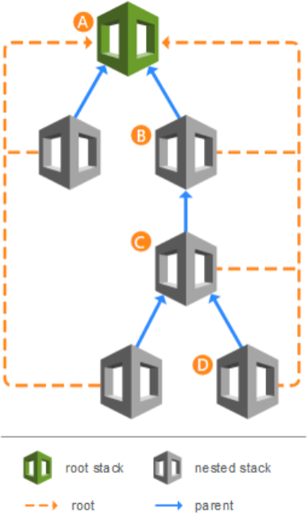
In summary, nested stacks are a good way to handle large environments that encompass multiple stacks.
For more information, see the AWS CloudFormation Documentation.

CloudFormation Sample - Template Code
The following CloudFormation template is the template that was used in this course. We’ve provided it here in case you want to see it or keep it for reference. For more information, see the AWS CloudFormation API Reference documentation.
AWSTemplateFormatVersion: 2010-09-09
Description: Sample template that contains common networking components
Parameters:
VpcCidr:
Type: String
Default: 10.10.0.0/16
PublicSubnetCidr:
Type: String
Default: 10.10.1.0/24
Resources:
#################################################
### Start - Create lab network resources ###
#################################################
Vpc:
Type: AWS::EC2::VPC
Properties:
CidrBlock: !Ref VpcCidr
EnableDnsSupport: true
EnableDnsHostnames: true
InstanceTenancy: default
Tags:
- Key: Name
Value: Lab VPC
#-----Public subnet resources-----#
InternetGateway:
Type: AWS::EC2::InternetGateway
Properties:
Tags:
- Key: Name
Value: Internet Gateway
AttachInternetGateway:
Type: AWS::EC2::VPCGatewayAttachment
Properties:
VpcId: !Ref Vpc
InternetGatewayId: !Ref InternetGateway
PublicSubnet:
Type: AWS::EC2::Subnet
Properties:
VpcId: !Ref Vpc
CidrBlock: !Ref PublicSubnetCidr
MapPublicIpOnLaunch: true
AvailabilityZone: !Select
- 0
- !GetAZs
Tags:
- Key: Name
Value: Public Subnet
PublicRouteTable:
Type: AWS::EC2::RouteTable
Properties:
VpcId: !Ref Vpc
PublicRoute:
Type: AWS::EC2::Route
DependsOn: AttachInternetGateway
Properties:
RouteTableId: !Ref PublicRouteTable
DestinationCidrBlock: 0.0.0.0/0
GatewayId: !Ref InternetGateway
PublicSubnetRouteTableAssociation:
Type: AWS::EC2::SubnetRouteTableAssociation
Properties:
SubnetId: !Ref PublicSubnet
RouteTableId: !Ref PublicRouteTable
############################################
### End - Create lab network resources ###
############################################

AWS CloudFormation Templates
- CloudFormation templates are declarative IaC resources. You describe what infrastructure you want (EC2 instances, VPCs, IAM roles, etc.), and AWS automatically provisions it for you.
- They are written in JSON or YAML and act like blueprints.
- Key difference: You don’t write step-by-step commands; instead, you define the desired end state, and AWS figures out the steps.
- When to use:
  - For complex, multi-resource environments (e.g., a full stack with networking, compute, and storage).
  - When you need repeatability across teams or accounts.
  - For compliance and governance, since templates can be version-controlled and audited.

Scripting (e.g., AWS CLI or SDKs)
- Scripts are imperative IaC resources. You write out how to build infrastructure step by step (e.g., run this command to create an EC2 instance, then another to attach a security group).
- They’re flexible and can include logic, loops, and conditions.
- Similarity to CloudFormation: Both automate infrastructure and reduce manual effort.
- When to use:
  - For smaller, one-off tasks (e.g., launching a test EC2 instance).
  - When you need fine-grained control or custom logic.
  - For quick automation without needing a full template.

Comparison Table
Feature | CloudFormation Templates | Scripts (CLI/SDK)
Approach | Declarative (define end state) | Imperative (step-by-step commands)
Format | JSON/YAML | Bash, Python, etc.
Best for | Complex, repeatable stacks | Small, custom tasks
Governance & Compliance | Strong (version control, auditing) | Limited
Flexibility | Less flexible, but consistent | Highly flexible, but error-prone

In short:
- Use CloudFormation when you want a blueprint for consistent, repeatable infrastructure.
- Use scripts when you need quick, flexible automation for specific tasks.

CloudFormation Template Example (YAML)
This defines an EC2 instance with Nginx installed via user data. Notice how you describe the desired state and AWS handles the rest.
AWSTemplateFormatVersion: '2010-09-09'
Description: Simple EC2 instance with Nginx

Resources:
MyEC2Instance:
Type: AWS::EC2::Instance
Properties:
InstanceType: t2.micro
ImageId: ami-0abcdef1234567890
SecurityGroupIds:
- sg-0123456789abcdef0
SubnetId: subnet-0abc123456789def0
IamInstanceProfile: StudentEC2Profile
Tags:
- Key: Name
Value: Nginx
UserData:
Fn::Base64: |
#!/bin/bash
yum install -y nginx
systemctl enable nginx
systemctl start nginx

Script Example (AWS CLI)
Here you tell AWS step by step how to create the same instance.
aws ec2 run-instances \
--image-id ami-0abcdef1234567890 \
--instance-type t2.micro \
--security-group-ids sg-0123456789abcdef0 \
--subnet-id subnet-0abc123456789def0 \
--associate-public-ip-address \
--iam-instance-profile Name=StudentEC2Profile \
--tag-specifications 'ResourceType=instance,Tags=[{Key=Name,Value=Nginx}]' \
--user-data file://user-data.txt

Key Takeaways
- CloudFormation: Blueprint style, repeatable, great for complex stacks.
- Scripts: Step-by-step, flexible, great for quick tasks or custom logic.
- Similarity: Both automate infrastructure and reduce manual effort.

👉 This side-by-side comparison makes it easy to explain in your assignment: CloudFormation is declarative (what you want), while scripts are imperative (how to do it).

EC2 Instance Metadata Commands used in the last video
The following list of commands was used in the previous video. We’ve provided the commands here in case you want to see it, or in case you are using a screen reader device or unable to view the video.
Commands:
curl -X PUT -H "X-aws-ec2-metadata-token-ttl-seconds: 21600" http://169.254.169.254/latest/api/token
TOKEN=`curl -X PUT -H "X-aws-ec2-metadata-token-ttl-seconds: 21600" http://169.254.169.254/latest/api/token`
echo $TOKEN
curl -H "X-aws-ec2-metadata-token: $TOKEN" http://169.254.169.254/latest/meta-data/
curl -H "X-aws-ec2-metadata-token: $TOKEN" http://169.254.169.254/latest/meta-data/ami-id
curl -H "X-aws-ec2-metadata-token: $TOKEN" http://169.254.169.254/latest/meta-data/instance-id
curl -H "X-aws-ec2-metadata-token: $TOKEN" http://169.254.169.254/latest/meta-data/placement/availability-zone
For more information, see Instance metadata and user data in the Amazon EC2 User Guide for Linux Instances.

